States of Matter

- Complete the following table to summarise the properties of solids, liquids and gases (some have been done for you)

State | Solid | Liquid | Gas
Arrangement | Very close together  Regular arrangement
Motion |  | Slip and slide over each other
Properties  (shape, volume & compressibility) | Definite shape  Not compressible | Definite volume | Spread out to fill available volume  Volume depends on the container  Compressible
Model of  particles |  | 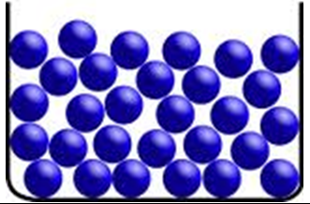

- a) The particles in which of the 3 states of matter have the most energy? ………….... b) In which states of matter are particles touching? ………….... and ………….. c) The particles in which of the 3 states of matter are furthest apart? …………....

- Solids, liquids and gases can be interconverted by either heating or cooling. Complete the following diagram by adding the names for the interconversions on the appropriate arrows.
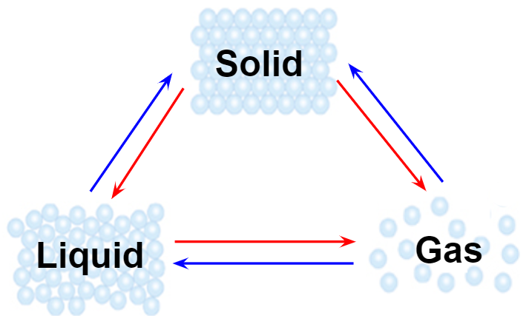

- What is the difference between evaporation and boiling? …………………...……………. ...…………………………………………………………………………………..………………
...…………………………………………………………………………………..………………

- Convert the following statements to chemical equations:

- Water turning into steam

...…………………………………………………………………………………..………………
- Iron (Fe) melting

...…………………………………………………………………………………..………………
- Dry ice turning into carbon dioxide gas

...…………………………………………………………………………………..………………
- Liquifying oxygen from the air

……....…………………………………………………………………………………..…………

